**The Equalizer & The Official Publication of Mabalacat City College**

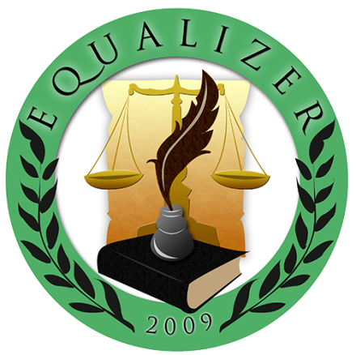

**Sprint #3**

Members:

GUNNING, IRENE L.

LAROGA, RUSSEL Z.

FRANCISCO, JULIUS D.

NICDAO, CHONNA D.

MARIN III, RUBEN F.

QUITALIG, ADRIAN F.

SANDIG, CEEJAY T.

ARCEO, SHARMAINE T.

TEAM EQUALIZER – APRIL 27, 2017

|  |  |  |
| --- | --- | --- |
| Scrum TEAM | SPRINT NAME AND DURATION | CHANGES |
| Team Equalizer | Equalizer Sprint #4  25/April/17  to  27/April/17 | **EQUA04- Navigation Tab for the User 30SP**   * Navigation Tab for user such as News, Opinion, Feature, Literary, Entertainment, Sports and Issues. |

**EQUA04- Navigation Tab for the User**

Navigation Tab for user such as News, Opinion, Feature, Literary, Entertainment, Sports and Issues.

**News Tab**

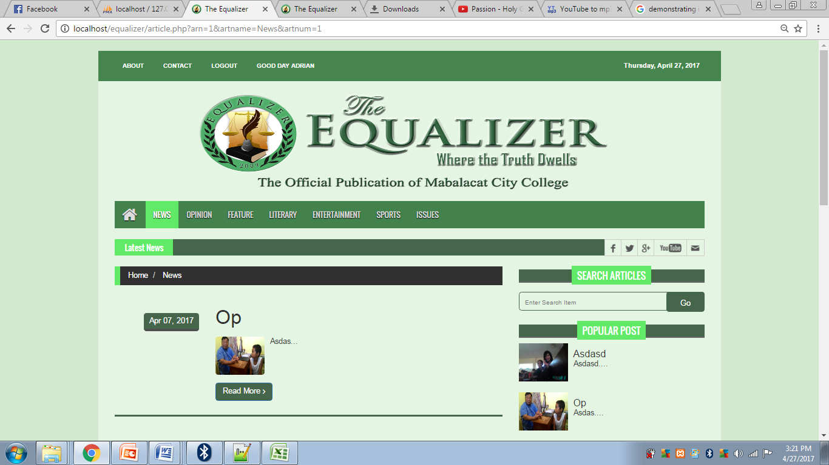

**Opinion Tab**

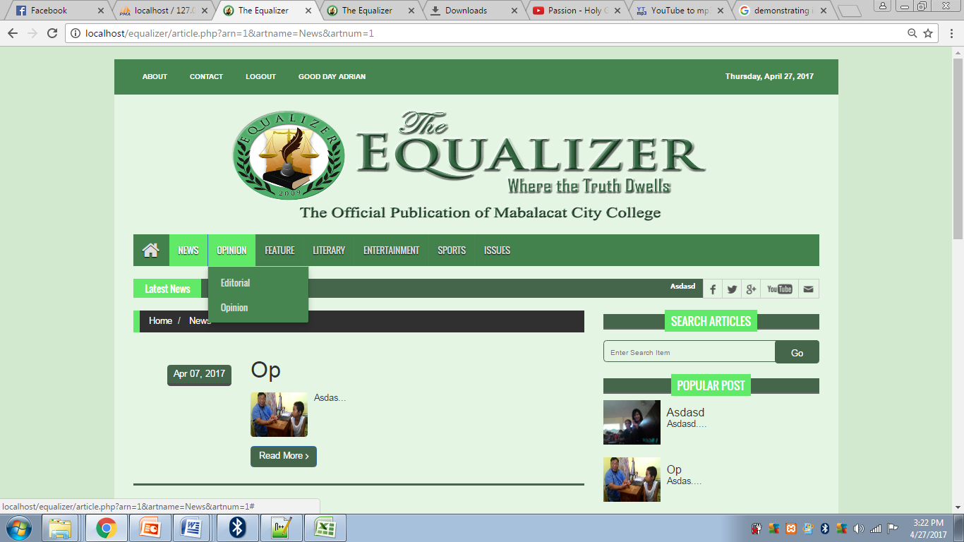

**Feature Tab**



**Literary Tab**

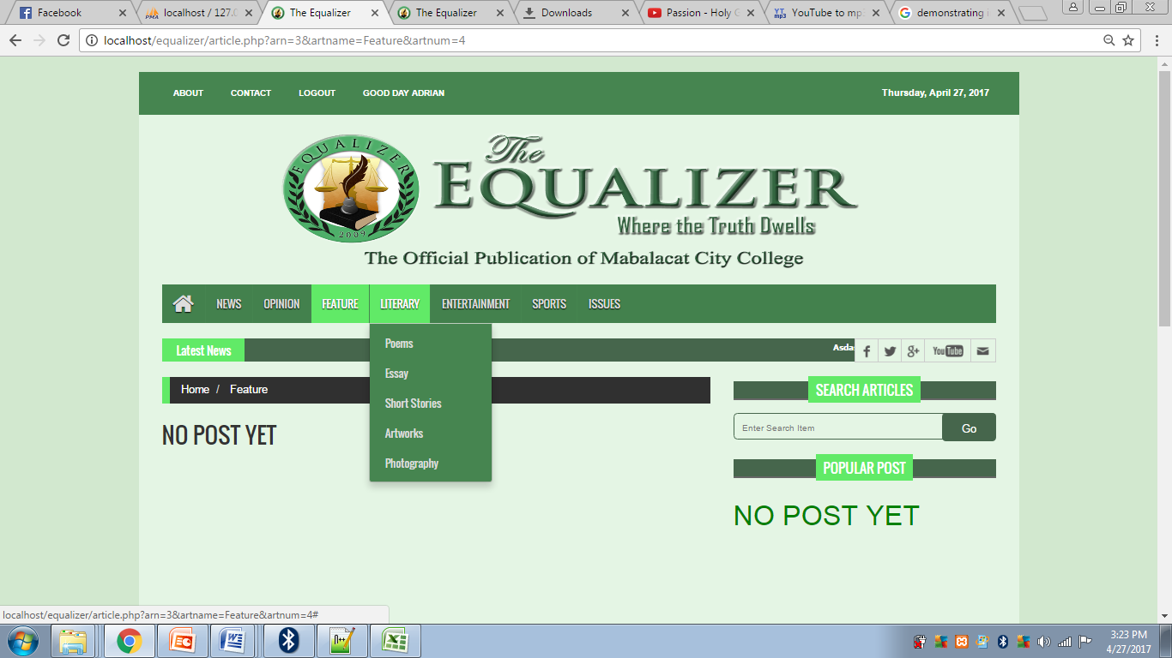

**Entertainment Tab**

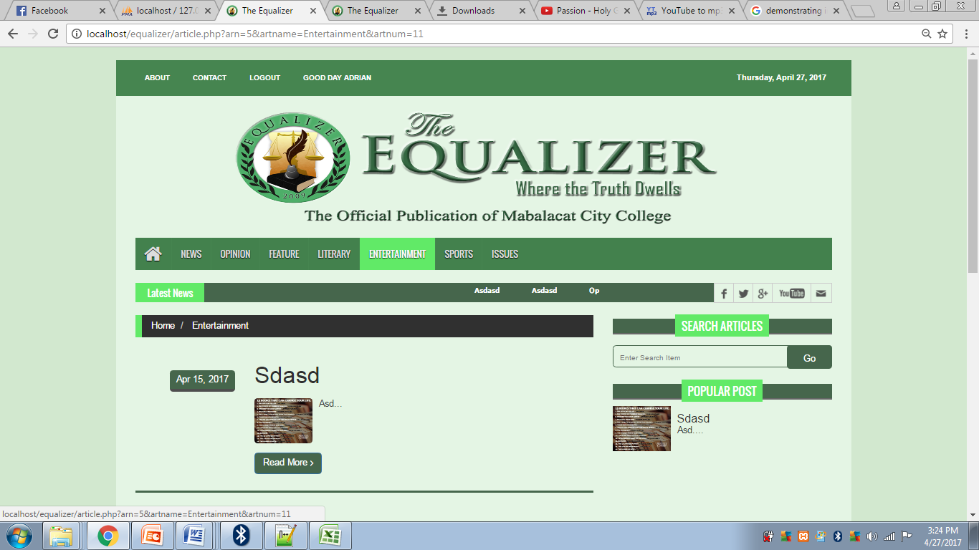

**Sports Tab**

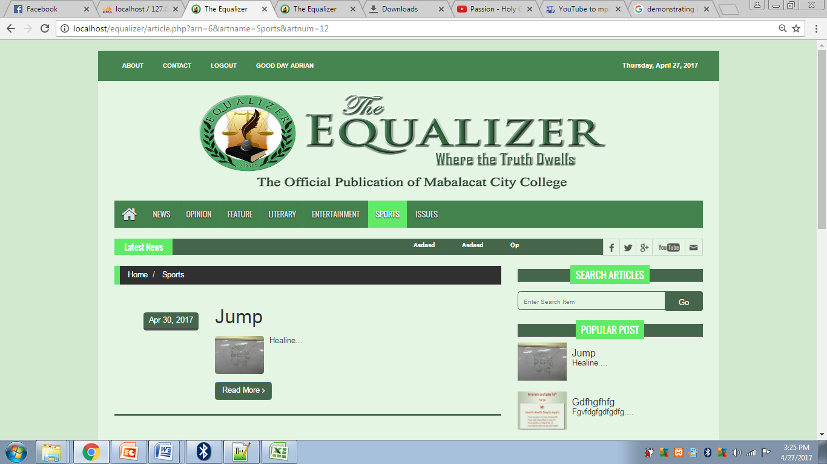

**Issues Tab**

